Project: Moffat Bay Marina | Developer tester: Max Jankowski
Course: CSD-460 | Peer Tester: Jordan Dardar
Description: Functional test plan for the redesigned Wait List page - public summary and logged-in join-wait-list flow | TEAM:  Alexander Baldree  Max Jankowski  Aftabur Rahman  Jordan Dardar
Date: 2026/09/21
To complete the test case plan, fill out the information for Project, Course, Description and Date in the header below.
.

Table Of Contents

Public Waitlist Summary with no Login Required………………………………………………………………………………2

Logged In Customer Can Join a Wait list and See Position…………………………..………………………………………4

Test 1 | Public Wait List Summary (No Login Required)
 | Test Objective: Verifies that the Wait List page displays accurate, real-time slip availability and wait-list counts for each slip size, pulled live from the database, without requiring a customer to log in, and that no customer names are ever displayed – per the project’s wait-list privacy requirement. | Developer: Max Jankowski  Date tested: 2026/09/21 | Peer tester: Jordan Dardar  Date tested: 2026/09/26
Step | Action | Expected results: | Developer pass/fail | Tester pass/fail  + Screenshot
1 | Open the browser window, ensuring you’re not actively logged into a session. Navigate to waitlist.html. | Page loads successfully and shows a “Customers Waiting by Slip Size” summary with one row per slip size 26 ft, 40 ft, 50 ft, no login prompt blocks the page. | Yes  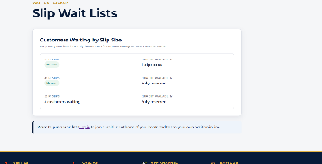 | Yes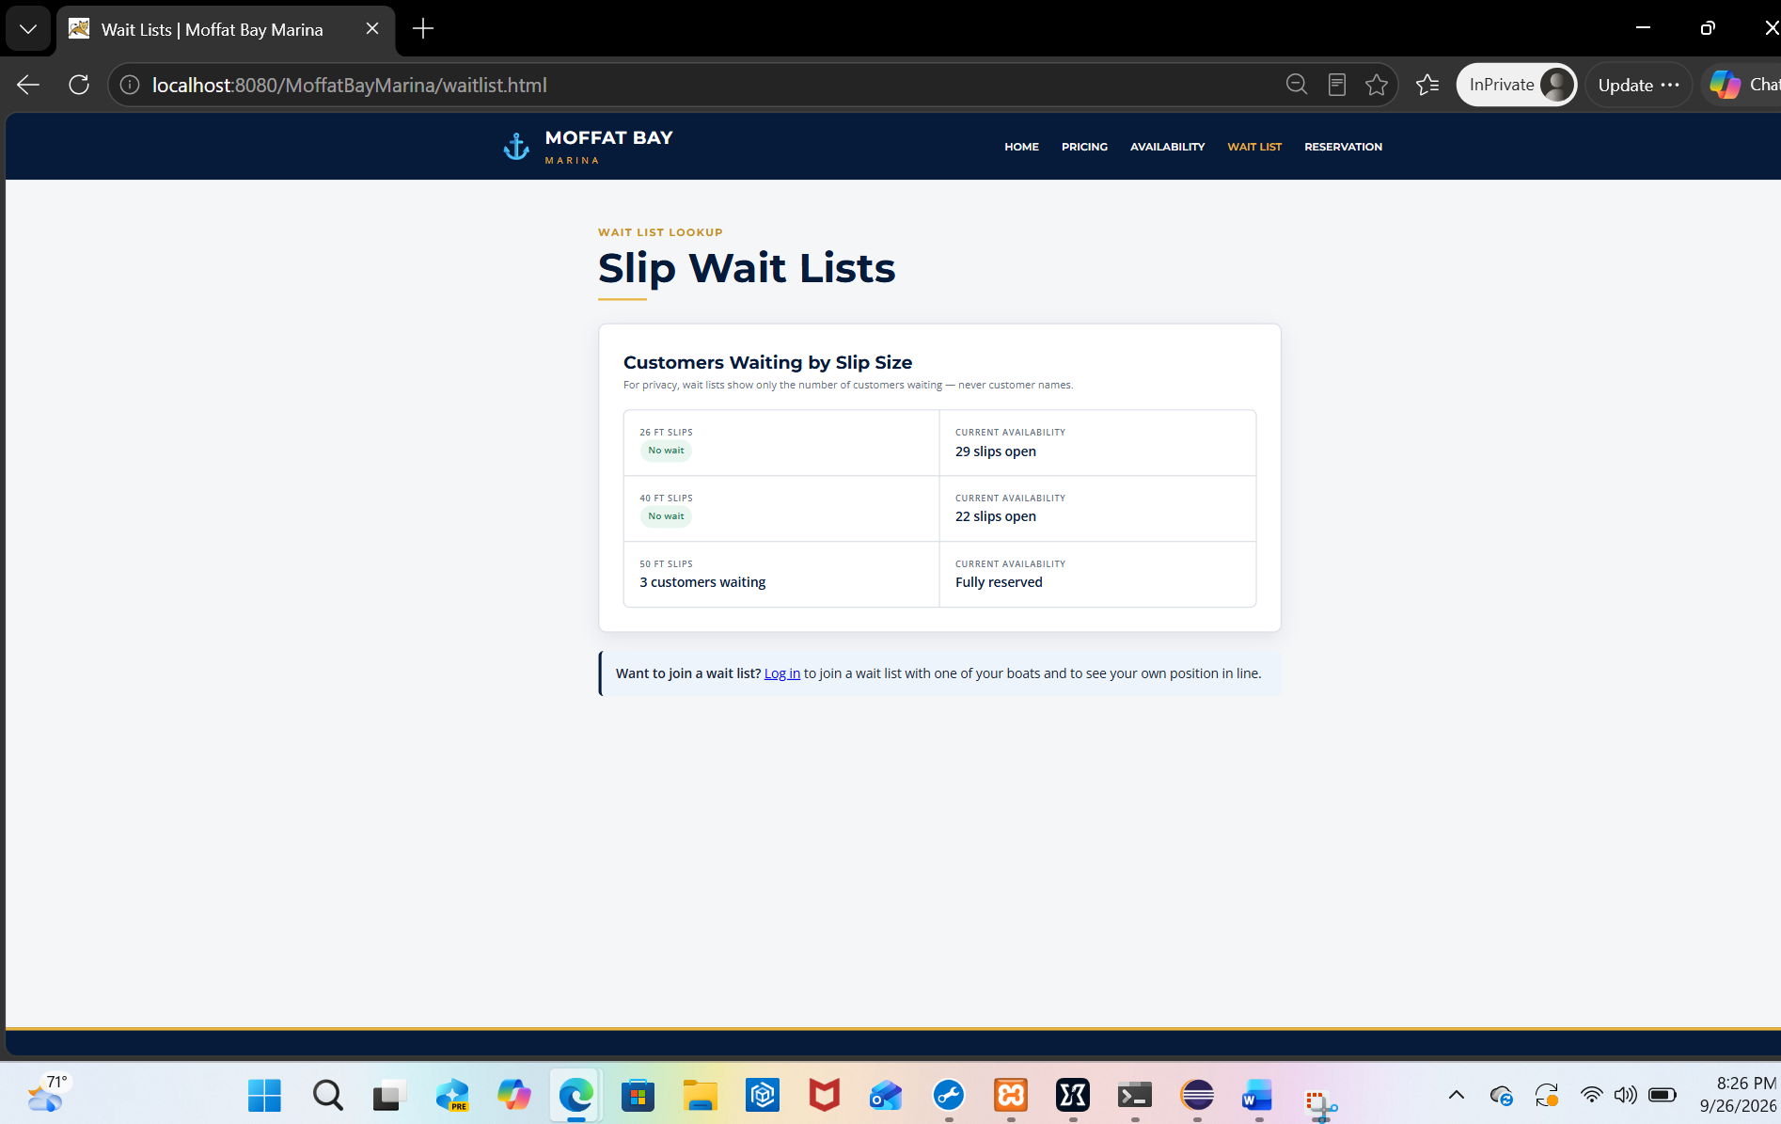
2 | In phpMyAdmin or the MySQL CLI, run SELECT slip_type_id, COUNT(*) FROM slips WHERE status='AVAILABLE' GROUP BY slip_type_id, and compare each result to the “Current Availability” value shown on the page for the matching slip size. | The available-slip count shown on the page matches the database query result exactly for all three slip sizes. | Yes  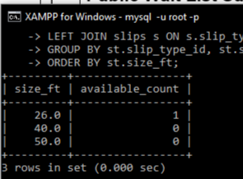 | Yes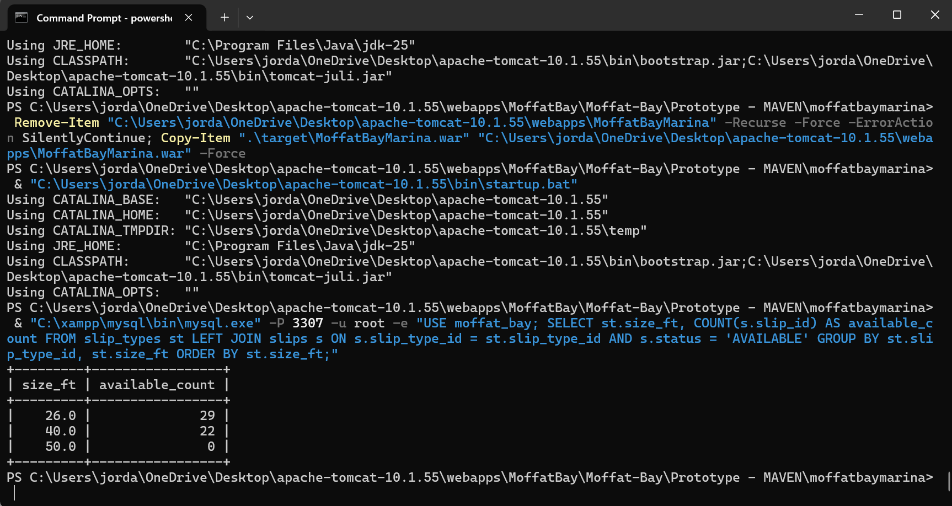
3 | Run SELECT slip_type_id, COUNT(*) FROM waitlist_entries WHERE status='WAITING' GROUP BY slip_type_id, and compare each result to the waiting-customer count shown on the page for the matching slip size. | The waiting-customer count shown on the page matches the database query result exactly for all three slip sizes, and no customer names or IDs appear anywhere in the summary section. | Yes  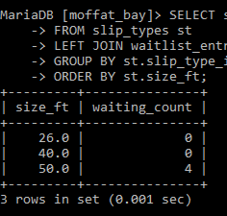 | Yes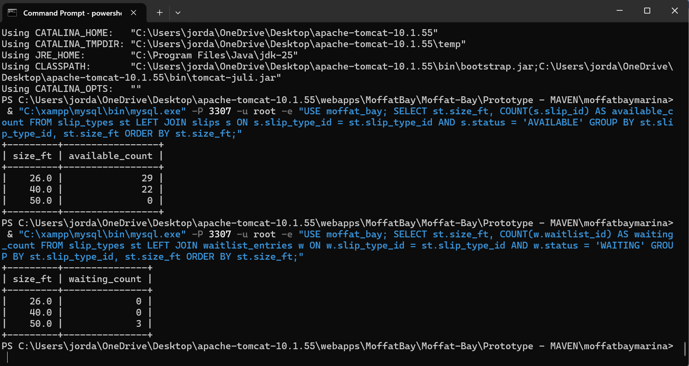
4 | While still not logged in, look for a “Join a Wait List” form or a “Your Wait List Entries” section on the page. | Neither section is visible; only the public summary and a “Log in to join a wait list” prompt are shown. | Yes  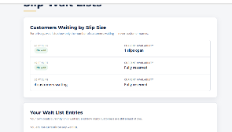 | Yes
5 | In a second browser tab, log in as another customer confirms a new reservation for a slip. Reducing that slip type’s AVAILABLE count by one, then return to the first tab and refresh waitlist.html. | The 26 and 40 ft slip sizes “Current Availability” count decreases by exactly one after refreshing, confirms the numbers are pulled live from the database rather than the old hardcoded marina-data.js prototype values. | Yes  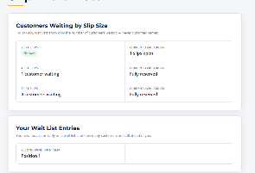 | Yes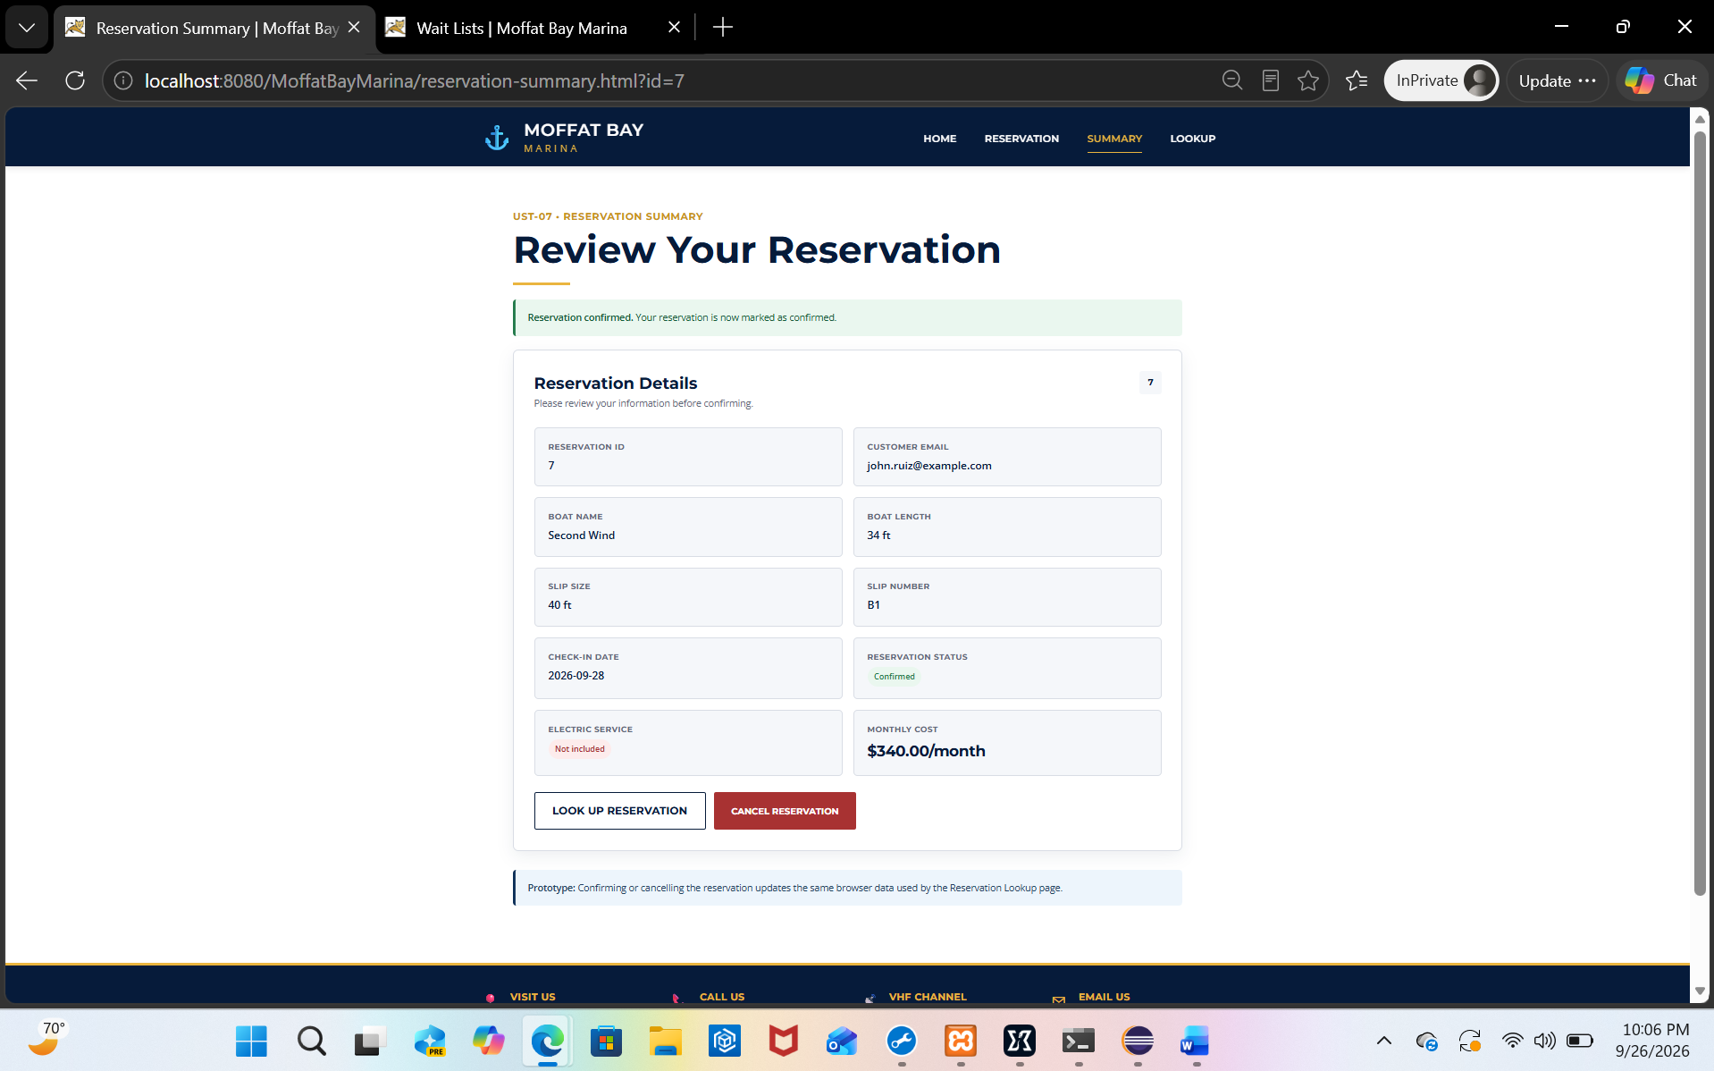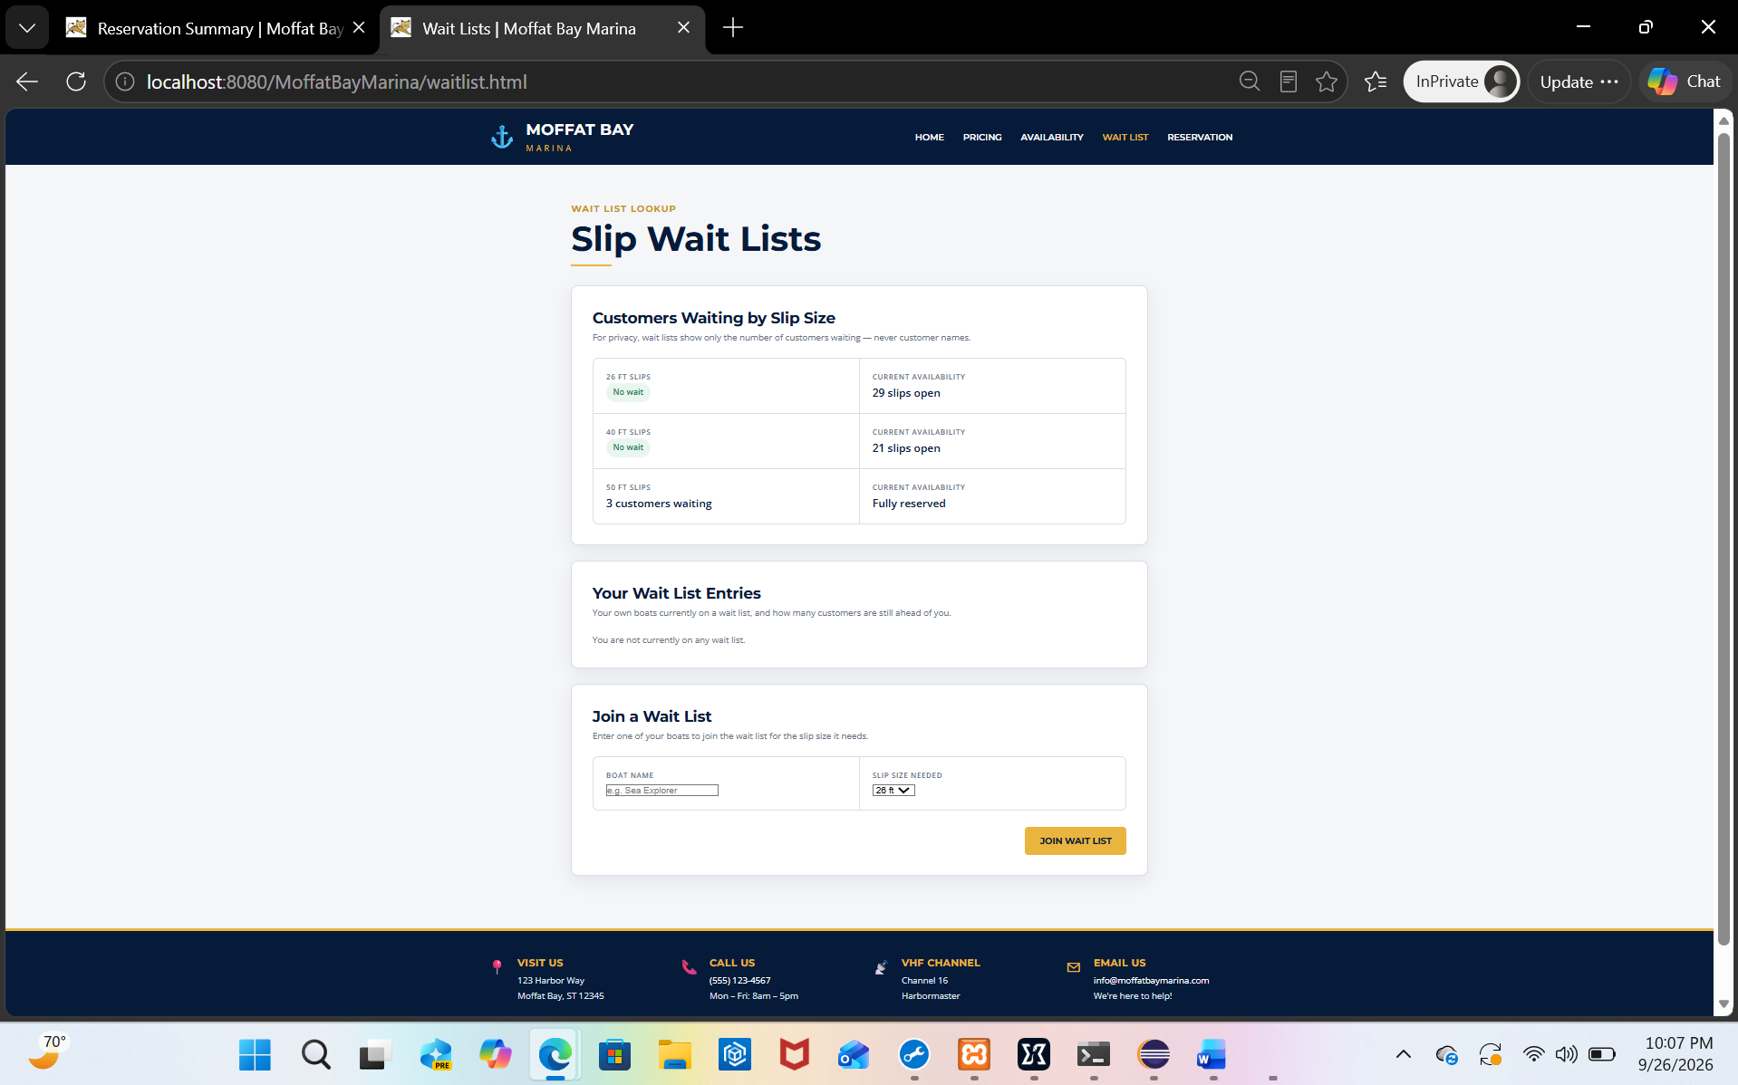
Comments | Comments should be substantive; this means there should be at least 2-3 well-structured sentences with constructive feedback.

Test 2 | Logged-In Customer Can Join a Wait List and See Their Position
 | Test Objective: Verifies that a logged-in customer can successfully join a slip-size wait list directly from the Wait List page, that duplicate sign-ups for the same boat/slip size are blocked, and that the customer’s new entry and current queue position are accurately returned and displayed. | Developer: Max Jankowski  Date tested: 2026/09/23 | Peer tester: Jordan Dardar  Date tested: 2026/09/26
Step | Action | Expected results: | Developer pass/fail | Tester pass/fail
1 | Log in as an existing customer already on a wait list in this case (henry.morrison@example.com, we have him on the 50 ft wait list) and navigate to waitlist.html. | The page shows both a “Join a Wait List” form and a “Your Wait List Entries” section, and Henry’s existing 50 ft entry appears in “Your Wait List Entries” with a position number. | Yes  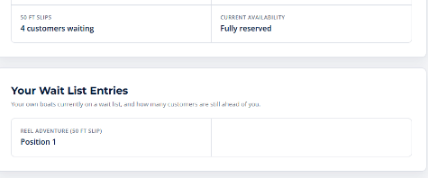 | Yes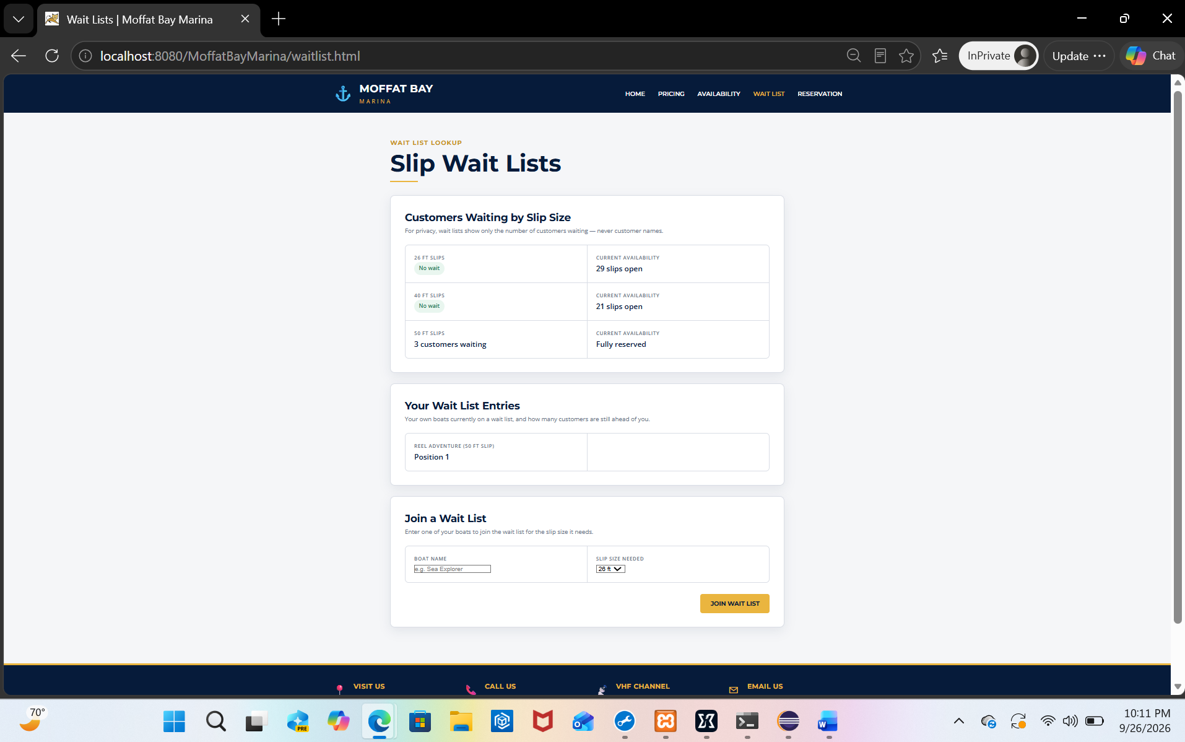
2 | In the “Join a Wait List” form, enter Henry’s existing boat name and select the 50 ft slip size – the same boat/slip-size combination he’s already waiting on – then submit. | The submission is rejected with a message such as “An active waitlist entry already exists for this boat and slip size,” confirming the duplicate-entry check still works from the new UI. | Yes  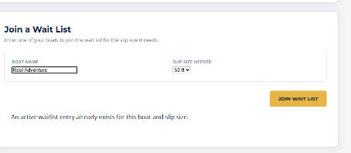 | Yes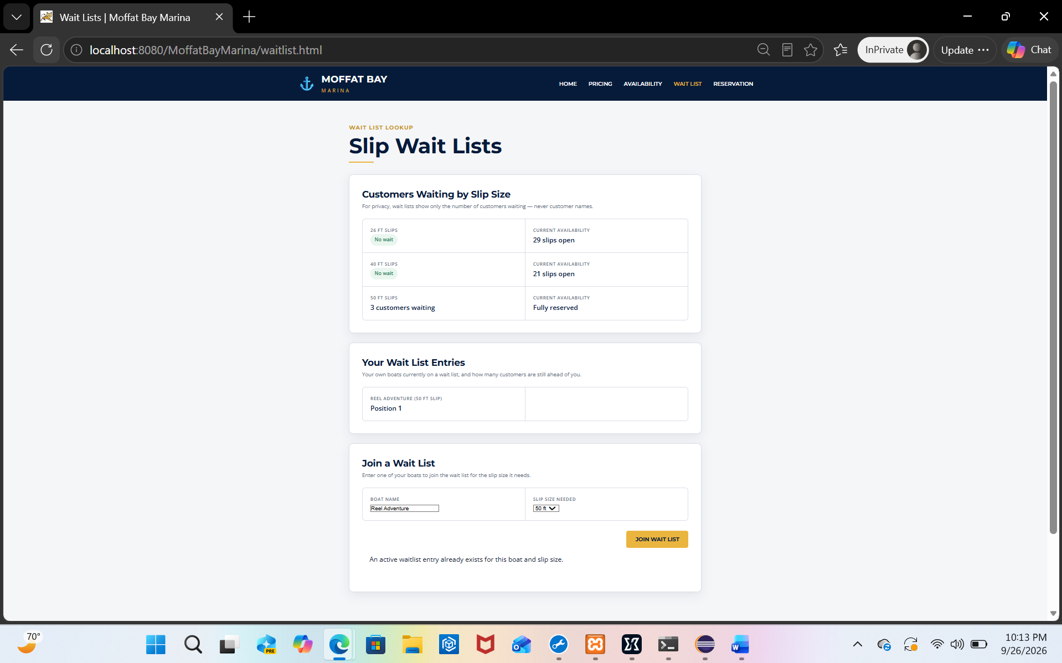
3 | Log out, then log in as a different seeded customer who is not currently on any wait list, fill out the “Join a Wait List” form with their real boat name and an available slip size, and submit. | The form succeeds, a confirmation message is shown (“You have been added to the waitlist.”), and the “Your Wait List Entries” section refreshes to show the new entry along with its queue position. | Yes  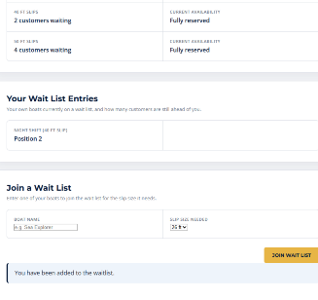 | Yes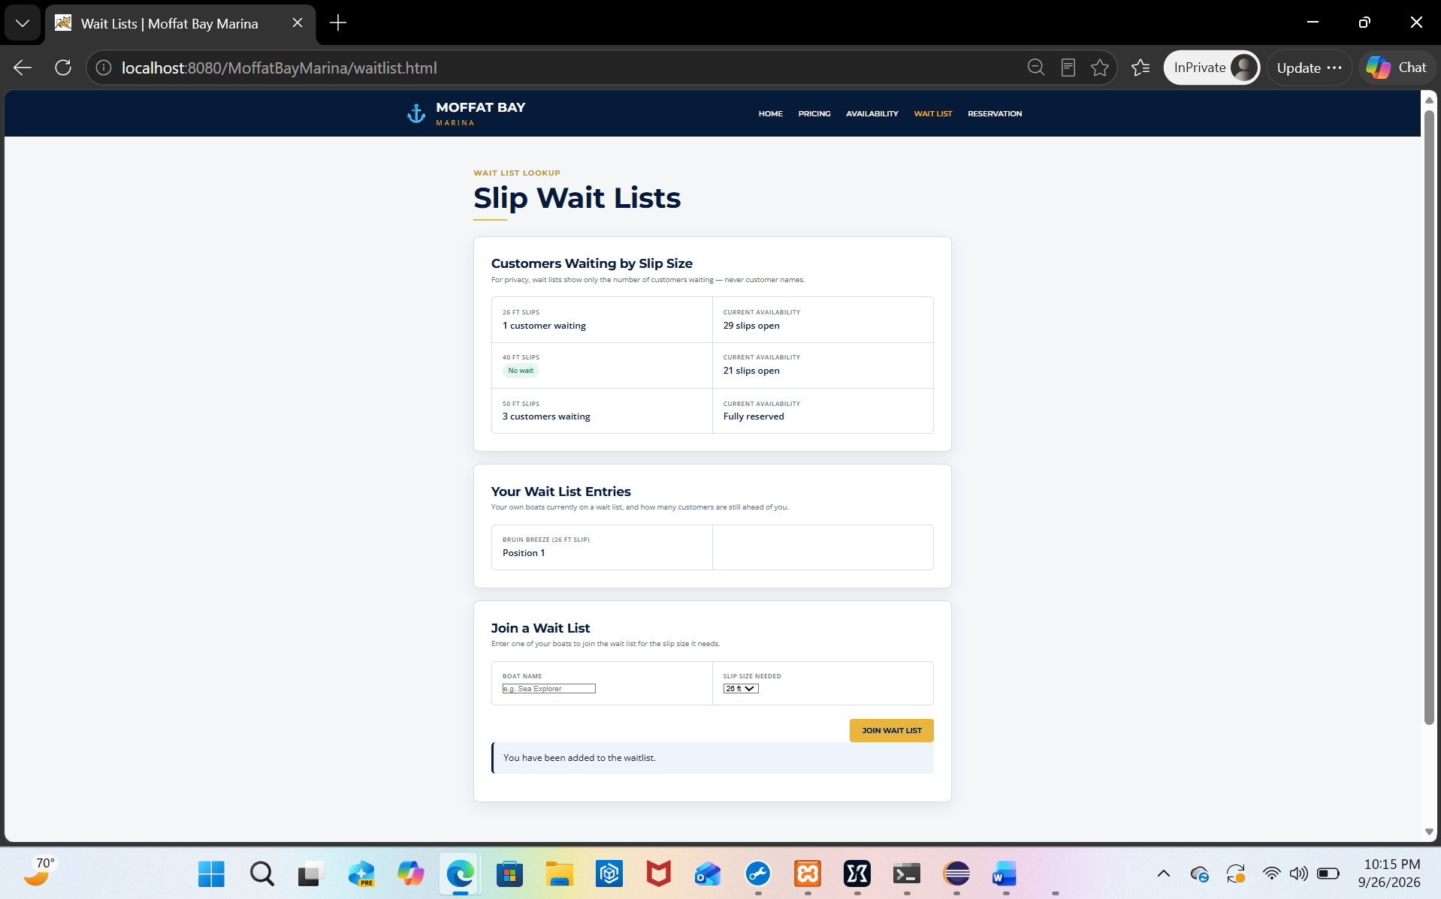
4 | Query the database directly: SELECT * FROM waitlist_entries WHERE customer_id = <that customer's id>. | Exactly one new row exists for that customer with the correct boat_id, slip_type_id, status = 'WAITING', and a joined_at timestamp. | Yes  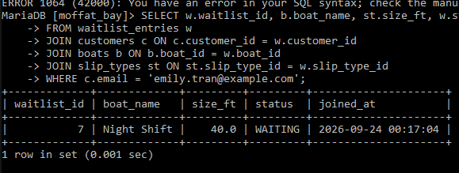 | Yes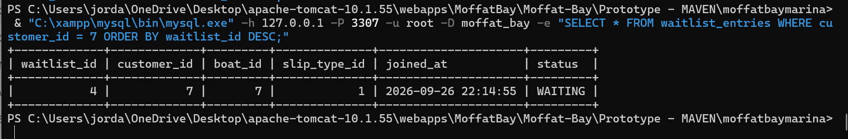
5 | Log out and reload the public wait list summary for that same slip size (as viewed in Test 1). | The waiting-customer count for that slip size has increased by exactly one compared to before this customer joined, confirming the public summary and the personal join flow read from the same live data. | Yes  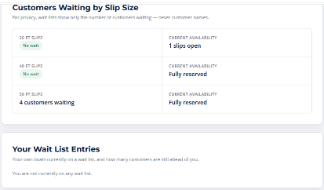 | Yes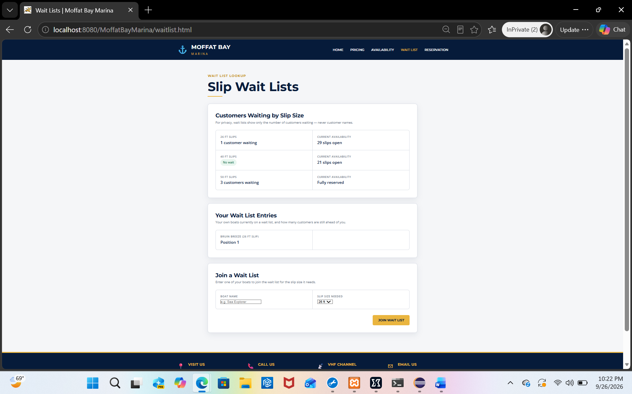
Comments | Comments should be substantive; this means there should be at least 2-3 well-structured sentences with constructive feedback.

